ESCOLA SECUNDÁRIA EÇA DE QUEIRÓS

Departamento de Língua Estrangeira
English
Name: Marco Silva Class: S - 13

- wake up
- get dressed
- have dinner
- cook
- get up
- comb his hair
- have break fast
- go back home
- watch TV
- take a shower
- have lunch
- sleep
- go to work
- brush his teeth
- go to bed

Mr. Parson always wakes up (a) at 7 a.m. Then he gets up (b) goes to the bathroom, takes a shower (c), gets dressed (d) and combs (e) his hair. He often has breakfast (f) before he goes to work (g).
Mr. Parson seldom goes to work (h) by car. He comes back home (i) at midday and has lunch (j) at 5 p.m. He often cooks (k). He usually has dinner (l) at 8 p.m. with his wife.
He always watches TV (m) before he goes to bed (n) to sleep. He never goes (o) to bed before kissing his children good night.
Find the words match them with the pictures and complete the text.

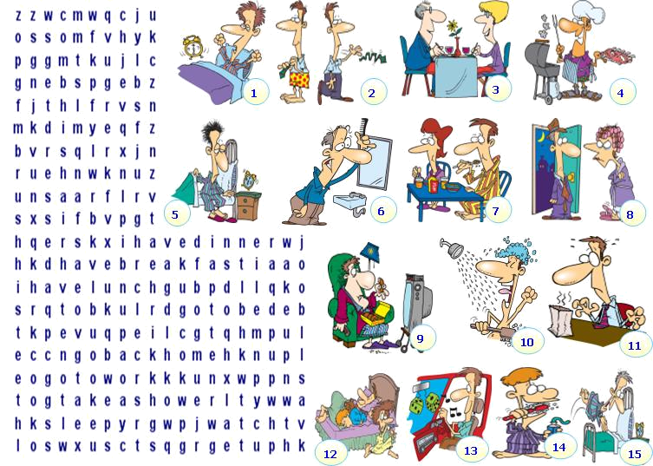

ESCOLA SECUNDÁRIA EÇA DE QUEIRÓS

Departamento de Língua Estrangeira

English

- Look at the images and make questions to the following answers. Please, do not forget to use the question-words you have learned.

- Q: When do you normally study?
A: I normally study at night, when everybody is asleep.

- Q: What does she like doing?
A: She likes ice skating.
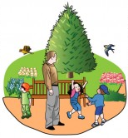
- Q: Where do they have lunch on Sunday?
A: On Sunday, they normally have lunch at the park.

- Q: How do you usually go to school?
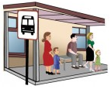
A: We usually go to school by bus.

- Q: What are his favourite sports?
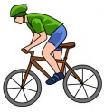
A: His favourite sports are swimming and cycling.

- Q*: Who has a headache?

Q**: What does Sarah have? or What is wrong with Sarah?
A: Sarah* has a headache** and she is going to the hospital in
the afternoon.
- Write these sentences in the negative:

- I speak English. I don’t speak English.
- Sheila sends e-mails to America. Sheila doesn’t send e-mails to America.
- My parents come from Germany. My parents don’t come from Germany.
- Peter likes science and technology. Peter doesn’t like science and technology.
- They speak Italian and French. They don’t speak Italian and French.

- Write the questions to the previous sentences. Follow the example:
E.g. “I speak English.”
Do you speak English?

- Does Sheila send e-mails to America?
- Do your parents come from Germany?
- Does Peter like science and technology?
- Do they speak Italian and French?

